Group Project

# One Sentence Description

Character (penguin) jumps across platforms (ice sheets) collecting points (fishes).

# What Does the Player Do?

2 players take it in turns to tap the screen, so the character can jump across platforms and collect points. Players will collect the points if it is their platform to land on. This can be colour coded so players can keep up with the game.

# Level Design

TBC – procedurally generated?

# Game Screens

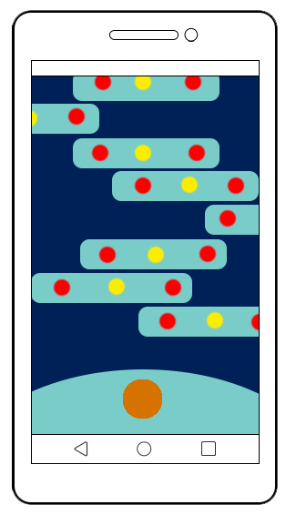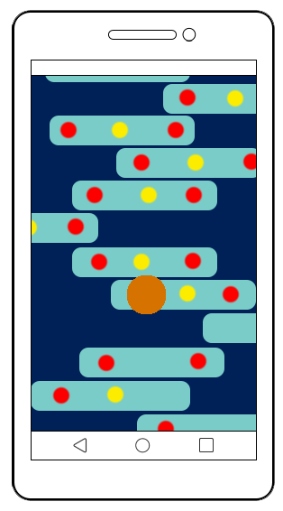

# Game Objects

## Player character

|  |  |
| --- | --- |
| **Actions/Behaviours/Mechanics** | **Description** |
| Jump (character) | Player must tap the screen on time |

|  |  |  |
| --- | --- | --- |
| **Variable** | **Description** | **Initial Value** |
| Jump Distance | How far the character can jump forward | ___ |
| Camera Speed | How fast the camera moves and if this accelerates over time | ___ |
| Platform Speed | How fast the platforms move left to right | ___ |

# Schedule

|  |  |  |  |  |
| --- | --- | --- | --- | --- |
| **Priority** | **No.** | **Tasks** | **Estimated time to learn (hrs)** | **Estimated time to complete (hrs)** |
| **High** |  | Prototype ready for play testing | **2** | **4** |
|  |  | Explicit theme to help with prototyping and concept art |  | **4** |
|  |  | Alternative themes (if there’s time to program them, and depending on play test feedback) |  | **2** |
| **Medium** |  | Concept art for environment, character and collectables |  | **2** |
|  |  |  |  |  |
|  |  |  |  |  |
| **Low** |  |  |  |  |
|  |  |  |  |  |
|  |  |  |  |  |
| **Total** |  |  | **2** | **12** |

(Subject to change each week)